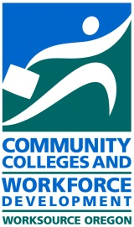
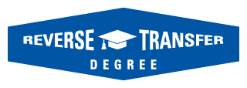
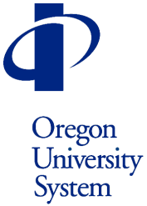

Dear Registrar:
Thanks to the funding Oregon received through the Lumina Credit When It’s Due grant, Oregon’s public community colleges and universities have begun to offer students the option of obtaining a degree through “Reverse Transfer.” This recognizes students’ achievements with an associate’s degree after they have transferred to a 4-year school and have accumulated the credits needed to fulfill the 2-year degree program requirements. It also recognizes the degree completion for the community college, which receives no “credit” for the degree through current data measures tracking completions. We would be happy to talk with you about this work, or please visit http://www.ous.edu/stucoun/transfer/reversetransfer which lists key contacts at all participating colleges and universities.
Currently 10 Oregon community colleges are doing Reverse Transfer via the grant but we want to make sure all community colleges know they may participate, too! In an effort to spread the word about this opportunity to all public campuses in the state, we are pleased to present these marketing tools for Project Oregon Reverse Transfer (PORT). Contained herein are posters and flyers for you to distribute throughout campus to inform students about this exciting opportunity. We also have the PORT graphic for use on your website as well as the flyer so you may customize it with your campus contact information, so please just let us know if you would like those pieces.
Thank you for all the work you do for our students. Please let us know if you have any questions.
Best,
Elizabeth Joe
Elizabeth Cox Brand, PhD Joseph Holliday, EdD
Project Oregon Reverse Transfer, state lead Assistant Vice Chancellor
Director, Research & Communications Student Success Initiatives
Oregon Department of Community Colleges and Oregon University System
Workforce Development joe_holliday@ous.edu
Elizabeth.coxbrand@state.or.us

